ALL INDIA ASSOCIATION FOR CHRISTIAN HIGHER EDUCATION
List of Office Bearers and Executive Board Members for the Triennium
January 2025 to December 2027

AIACHE’s First Online EB Meeting on January 30 at 6:30 PM

S.No. | Name & Address | Contact Details
 | GENERAL SECRETARY
1 | Rev Dr Xavier Vedam SJ  General Secretary  AIACHE  39 Institutional Area  D-Block, Janakpuri  New Delhi – 110 058 | 94447 61101, 97870 01209  aiache2011@gmail.com,  vedamvx@gmail.com | 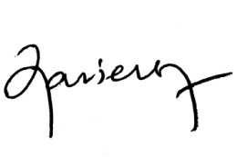
 | PRESIDENT
 | Dr. Sr. M. Rashmi A.C.  Principal,  Patna Women's College (Autonomous)  Bailey Road  Patna – 800001  Bihar | 9473027965  principalpwc@patnawomenscollege.in | 
1 | VICE PRESIDENT
 | Rev Dr Praveen Martis SJ  Principal  St Aloysius College (Autonomous)  Kodialbail  Mangalore - 575003  Karnataka | 9901483231  aloysius.principal@gmail.com,  principal@staloysius.edu.in  praveenmartis@gmail.com, | 
2 | Dr Paul Wilson  Principal  Madras Christian College  Tambaram East  Chennai – 600 059 | 98414 26693  wilson@mcc.edu.in
 | TREASURER
1 | Dr. Chinkhanlun Guite  Bursar  St. Stephen’s College,  Delhi University North Campus,  Delhi-110007 | 97177 33405  bursar@ststephens.edu | 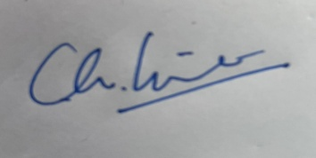
 | - ANDHRA REGION
 | MEMBERS
1 | Dr. Sr. Shiny K.P.,  Principal  JMJ College for Women (Autonomous),  Tenali | 9441613054  jmjtenali@gmail.com, shine_kp_jmj@yahoo.co.in,
 | - KARNATAKA REGION
 | MEMBERS
1 | Rev. Dr. Charles Lasrado SJ,  Principal,  St. Joseph’s College of Commerce (Autonomous), Bengaluru | 9448055264  info@sjcc.edu.in, principal@sjcc.edu.in | 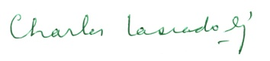
 | - KERALA REGION
 | MEMBERS
1 | Fr. Dr. Jestin K Kuriakose,  Principal,  Nirmala College Muvattupuza (Autonomous), Kerala | 94462 76764  nip_mvpa@yahoo.co.in, | 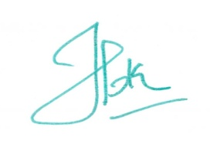
2 | Dr. Letha P Cheriyan,  Principal,  Mar Thoma College for Women,  Perumbavoor , Kerala | 94974 87331  mtcwpbr@yahoo.co.in,
 | - TAMIL NADU REGION
 | MEMBERS
1 | Rev. Dr A. Louis Arockiaraj SJ,  Principal,  Loyola College, Chennai | 9443973074  principal@loyolacollege.edu,
2 | Dr.V. Regina,  Principal,  Bishop Newbegin College of Education  Chennai | 8754482049  drreginapremkumar@gmail.com, bpnewbiginbedcol100@gmail.com
 | 5. EASTERN REGION
 | MEMBERS
1 | Dr. Madhumanjari Mandal  Principal  Scottish Church College  1 & 3 Urquhart Square  Kolkata - 700 006 | 98300 75960  principal@scottishchurch.ac.in | 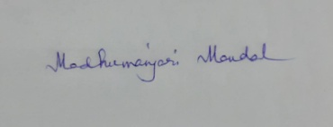
2 | Dr. Sr. A. Nirmala,  Principal,  Loreto College,  Kolkata | 6291 230 514  loretocollege1912@gmail.com | 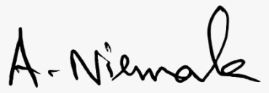
 | 6. NORTHERN REGION
 | MEMBERS
1 | Dr. Fr. Jesu Ben Anton Rose,  Principal,  St. Aloysius College (Autonomous),  Jabalpur | 9425155175  staloysiuscollege1951@gmail.com | 
2 | Prof. Shailendra Pratap Singh,  Principal,  St. John's College,  Agra | 9997768866  spsingh2000@gmail.com,stjohnscollegeagra@gmail.com | 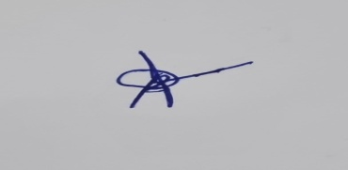
 | CO – OPTED MEMBERS
1 | Fr.Mariadoss SJ  Principal,  St. Joseph’s College,  Tiruchirappali | 9443343324  sjcprincipal.trichy@gmail.com, principal@mail.sjctni.edu
2 | Dr Rudolf Manih  Principal  Union Christian College  Barapani  Mehghalaya | 94361 08697, 87878 64569  manih11@yahoo.co.in,  uccmegh2017@gmail.com
3 | Rev. Dr Sebastian Karottupuram  Principal  Don Bosco College Maram  Maram, Senapati Dist  Manipur - 795 015 | 9436031127,  Whatsapp 9436031125, 8731085814  dbcmaram@gmail.com,  principal@dbcmaram.ac.in, | 